SUBASHREE.N-192521377
LAB EXPERIMENTS
EXP 17: HIGH LEVEL PROGRAMMING EXTENSIONS: FUNCTIONS
OUTPUT:
1:
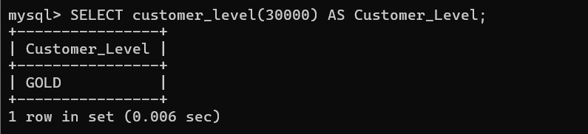
2:
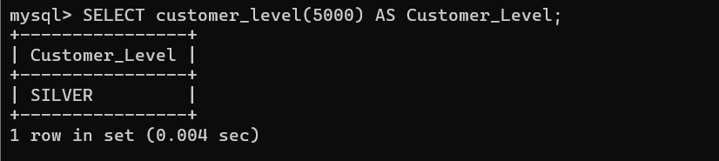
3:
